**Introduction**

Web Services testing can be performed using many approaches and Soap UI is one such free and open source testing tool that is used for functional and non-functional testing of web services.

As we know that Web Services are of two types:

1. SOAP (Simple Object Access Protocol)
2. RESTful (Representational State Transfer)

**Simple Object Access Protocol**

SOAP is a protocol for exchange of information. It is a standard protocol defined by the W3C (World Wide Web Consortium) Standard for sending and receiving web service requests and responses. It uses XML format to send and receive the request and hence the data becomes platform independent.

* The SOAP specification has been universally accepted as the standard transport protocol for messages processed by web services.
* There are two different versions of SOAP specification and both of them are widely used in service-oriented solutions.These two versions are SOAP v1.1 and SOAP v1.2.

A SOAP message is an XML document that consists of a mandatory SOAP envelope, an optional SOAP header, and a mandatory SOAP body.

The structure of a SOAP message is shown in the following diagram:

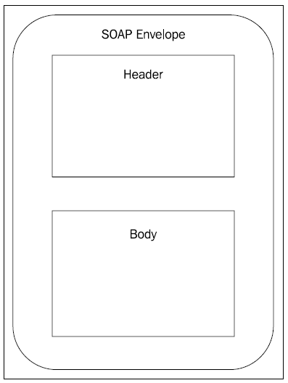

The SOAP Envelope is the wrapper element or root element which holds all the child elements inside a SOAP message.

The SOAP Header element is an optional block where the meta information is stored. Using the headers, SOAP messages are capable of containing additional information related to SOAP message.

**WSDL**

WSDL (Web Services Description Language) is an XML based language which will be used to

describe the services offered by a web service.

WSDL describes all the operations offered by the particular web service in the XML format.

It also defines how the services can be called, i.e what input value we have to provide and

what will be the format of the response it is going to generate for each kind of service.

**Testing Web Services**

Web service can be tested to verify both functional and non-functional requirements.